

Enter Contact Information Here | 1127 Lombard Blvd. San Francisco, CA 59802 | phone 555.555.5555 | fax 555.555.5555
Fall prevention program

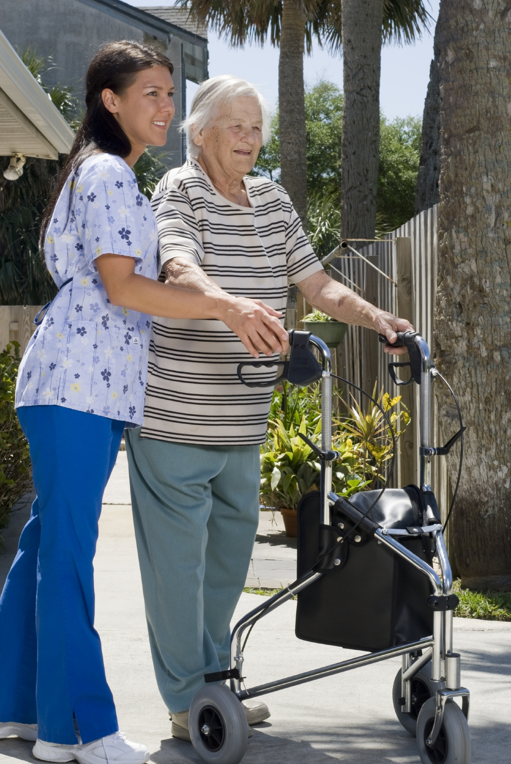
Problem
Step 2 – Care Giver Training
An aide is carefully chosen based on our needs assessment with caring compassion.
Hurricane Marketing Enterprises schedules a training session with the client, aide, and therapist. This keeps consistency in transfers and exercise while providing a chance to regain a level of independence.
Step 3 – RN Supervision/Monitor Progress*
Once home, a formalized RN Plan of Care is developed and monitored via supervisory visits This helps track compliance and progress via documentation to ensure we are providing the best services as promised!
*Services must be provided minimum 30 days to have RN assessment fee waived

- Over one-third of adults 65+ fall each year
- 20-30% of falls cause moderate to severe injuries
- In 2005, nearly 1.8 Million people 65+ were treated in ER’s for nonfatal injuries from falls.
- At least one-third of all falls involve environmental hazards in the home.
- Two-thirds of those who fell, will fall again within six months
Hurricane Marketing Enterprises recognizes the importance of fall prevention and has developed training, oversight, and procedures to help reduce the chances of injury.
By taking these steps, the chance for falls is greatly reduced and keeps our older adults safe.

Solution
Step 1 – Needs Assessment & Home Inspection
Hurricane Marketing Enterprises does a complimentary personalized need assessment and home inspection to ensure safety and reduced risk of repeat fall.
Home Inspection includes:
- Hygiene- Transfer Benches, Chairs, Hand Held Shower Head all need to be accessed
- Grab Bars- Properly installed in high risk areas
- Transfers- Are we properly prepared?
- Toileting- Procedures & proximity for ease of use.
- Entrances & Pathways – Getting In/Out, Reducing tripping hazards

Sources: Center of Disease Control – www.cdc.gov/homeandrecreationalsaftey/falls/adultfalls.html
Colorado State University – www.ext.colostate.edu/pubs/consumer/10242.html

FALL PREVENTION PROGRAM

